**N5 Project Design Report**

**Student number:** 2615649

**Name of application:** WD Revision

**Main file:** Homepage.html

**Product description**

**General Concept Description of WD Revision**

**What is it?**

The website I will be designing will be an interactive Computing Science revision resource for web design that includes tutorials, demonstrations and quizzes for HTML, CSS and JavaScript features as well as information on design concepts and principles.

The sections will contain the theory behind various topics supplemented by appropriate multimedia elements, such as images, videos or animation, and interactivity elements.

**How would you deliver it?**

It will be delivered through a website. The general structure of the website will be a homepage that will have a menu of different web design subtopics such as CSS, HTML or The 8 Golden rules. The user will then choose one of these topics where they will find text, some kind of multimedia element and some sort of interactivity that will show them an example of the topic, and a quiz where they can test their knowledge relating to the topic.

**Target users – Who is it aimed at?**

The target users for the website will primarily be Computing Science Students that have some kind of Introduction to Web Design module where they are required to learn the basics about HTML, CSS, JavaScript and general design concepts and principles.

The website is also targeted at Lecturers and Teachers that may wish to demonstrate some examples in class or anyone who wishes to learn about the basics of web design for that matter.

**Personas next page**

**Personas**

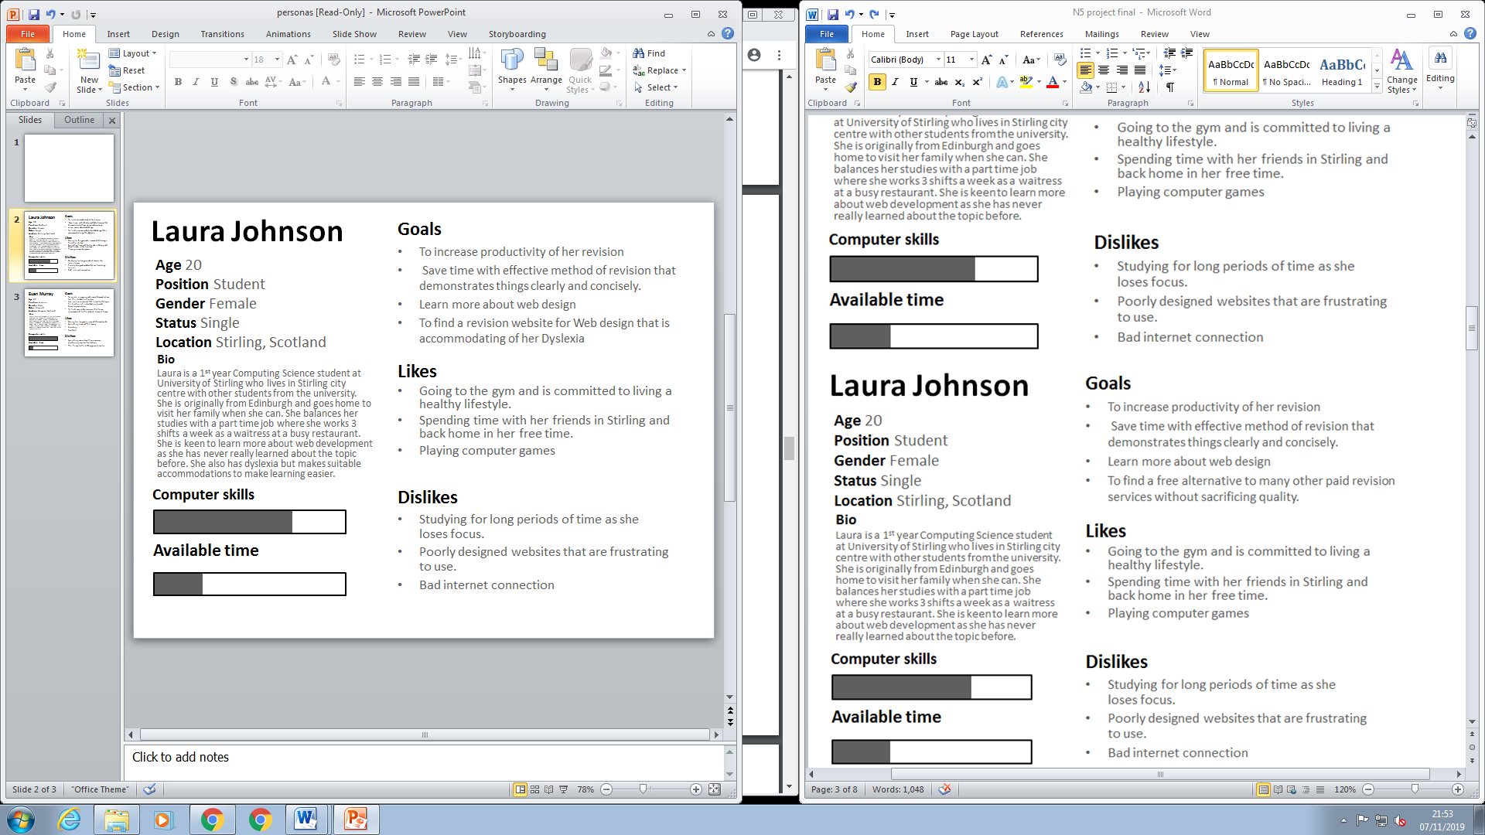

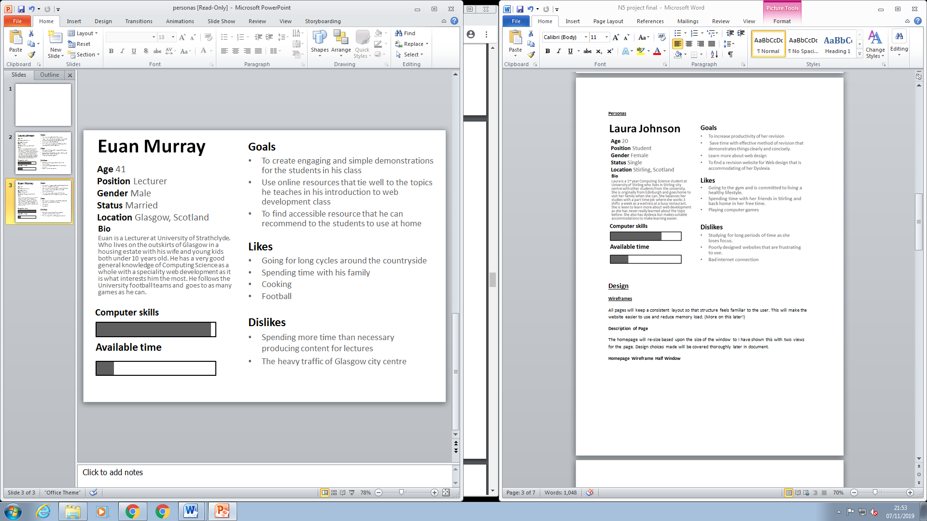

**Design**

**Wireframes**

All pages will keep a consistent layout so that structure feels familiar to the user. This will make the website easier to use and reduce memory load. (More on this later!)

**Description of Page**

The homepage will re-size based upon the size of the window to I have shown this with two views for the page. Design choices made will be covered thoroughly later in document.

**Homepage Wireframe Half Window >**

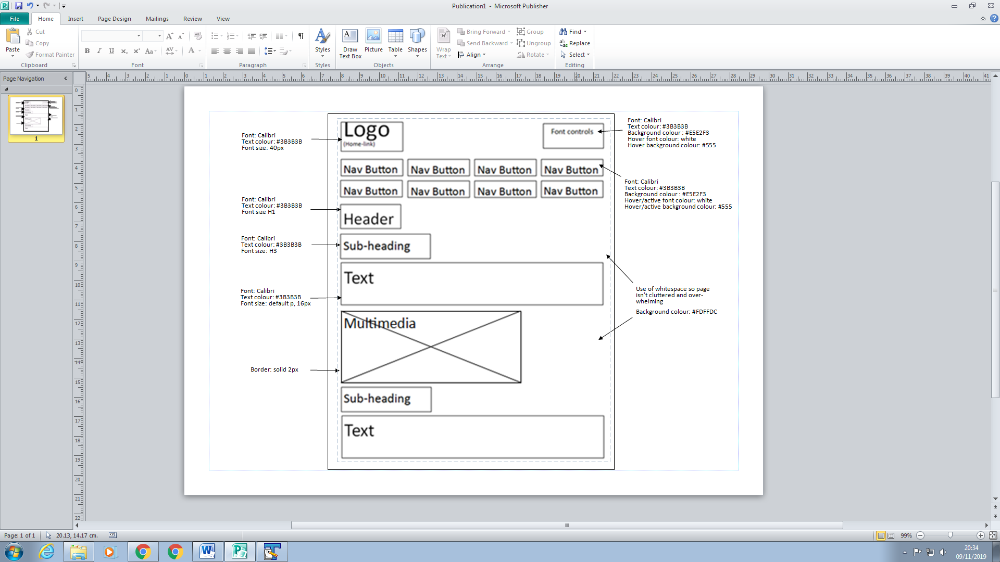

**Homepage Wireframe Full Window >**

All other annotations are the same as previous wireframes

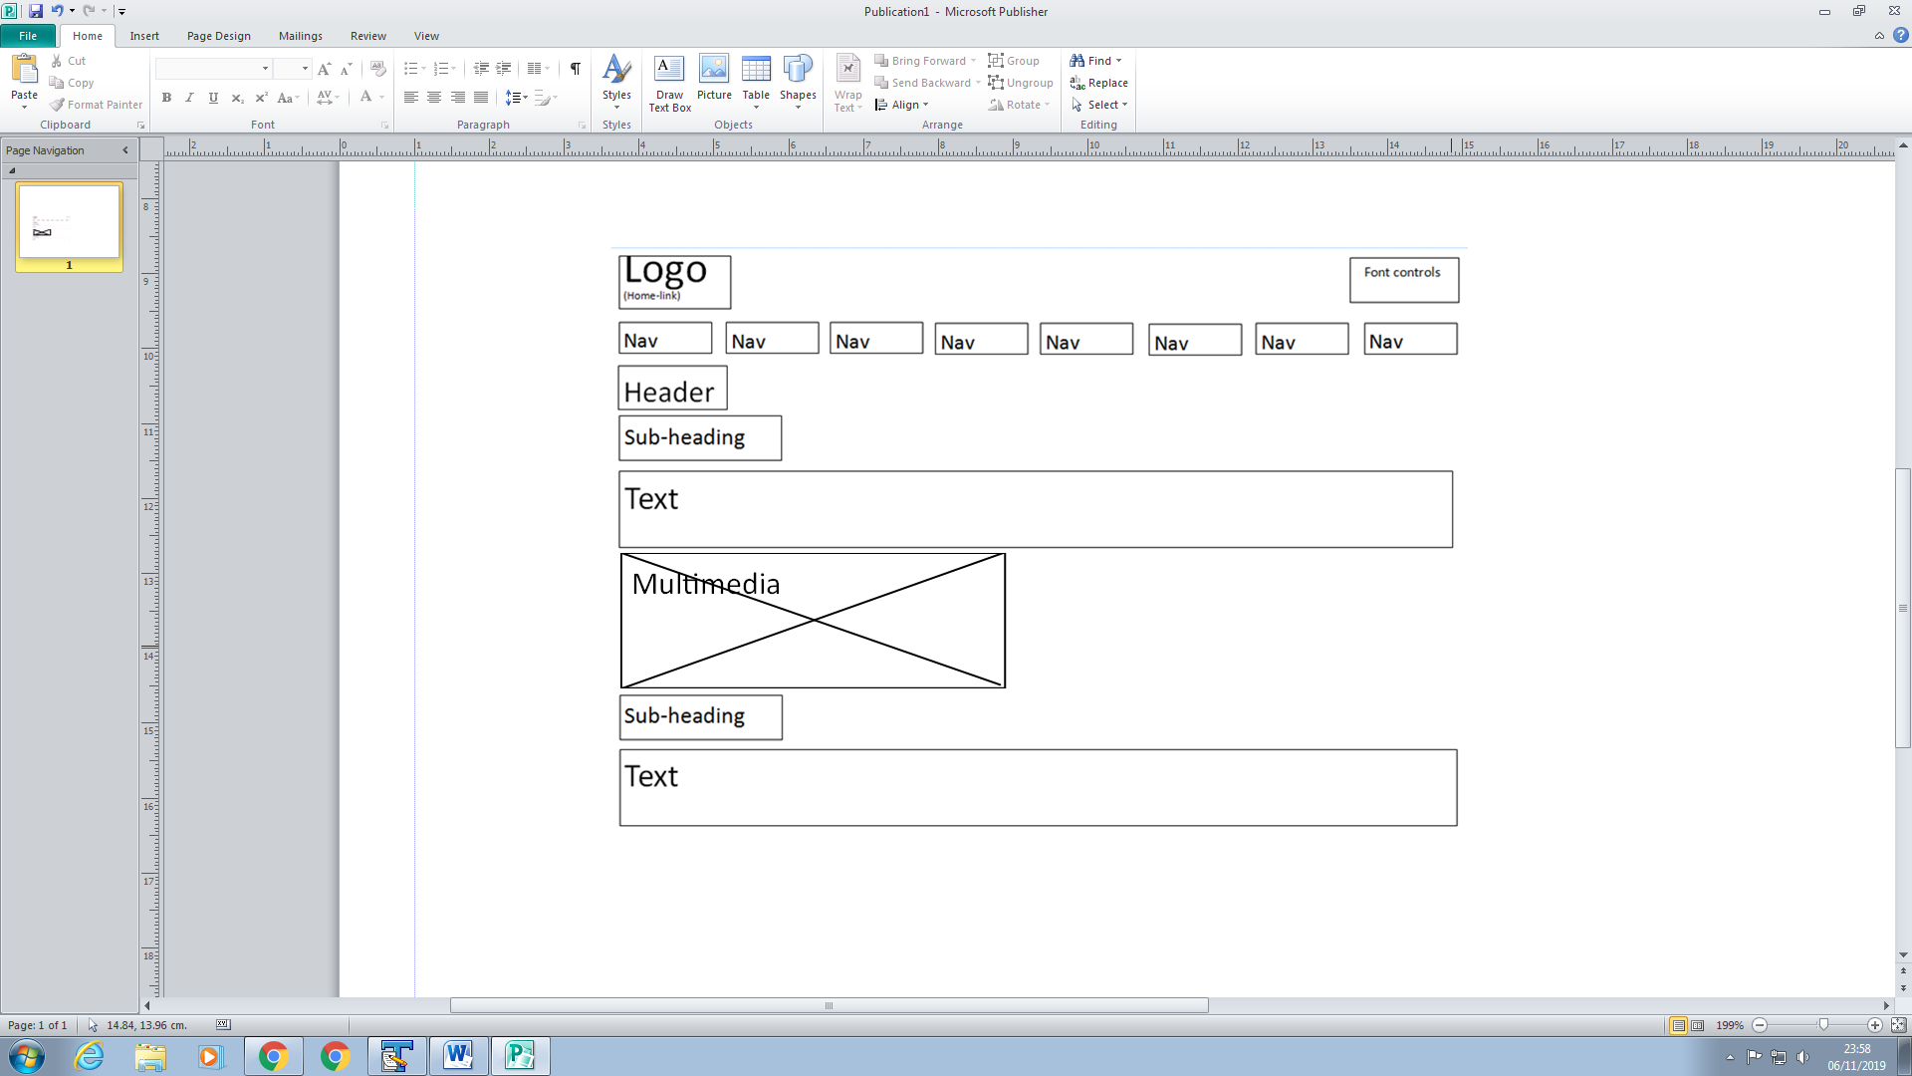

Content will adjust to fit the size of the window

**Content Pages Wireframe Half Window >**

**Description of Page:**

The homepage will re-size based upon the size of the window to I have shown this with two views for the page. Design choices made will be covered thoroughly later in document.

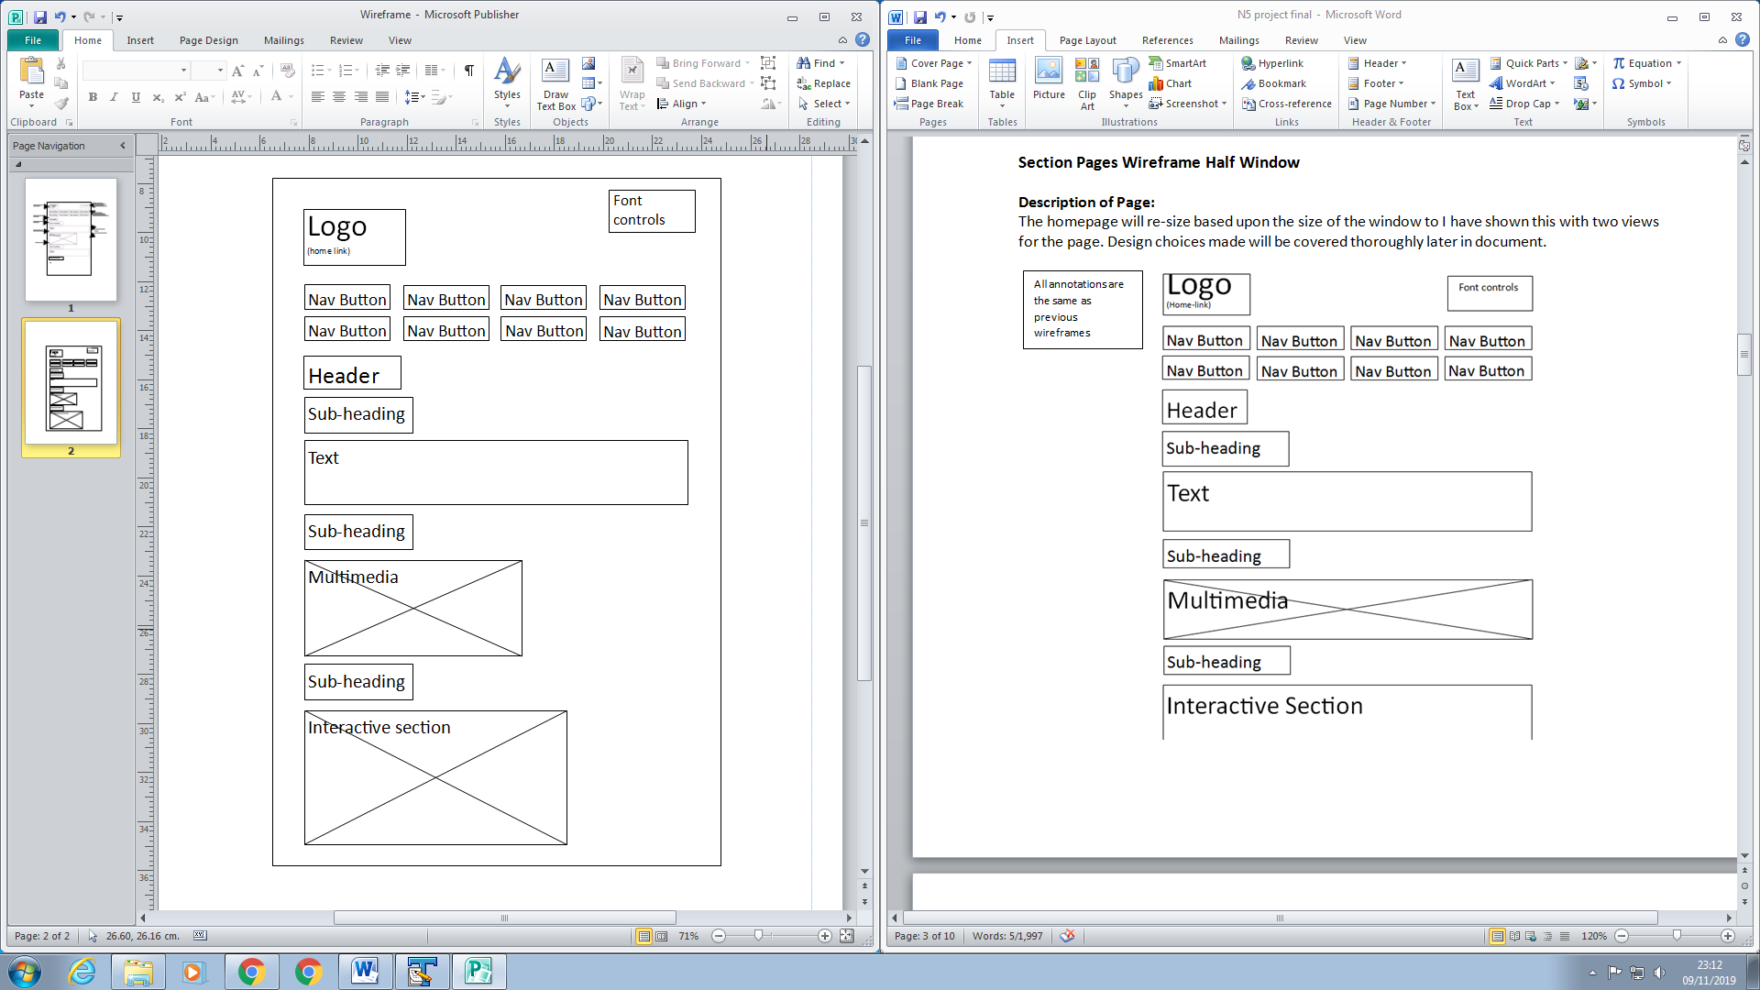

Interactive section will demonstrate something relating to the topic. Users can ’try out’ a feature of the section and complete a quiz

All other annotations are the same as previous wireframes

**Content Pages Wireframe Full Page >**

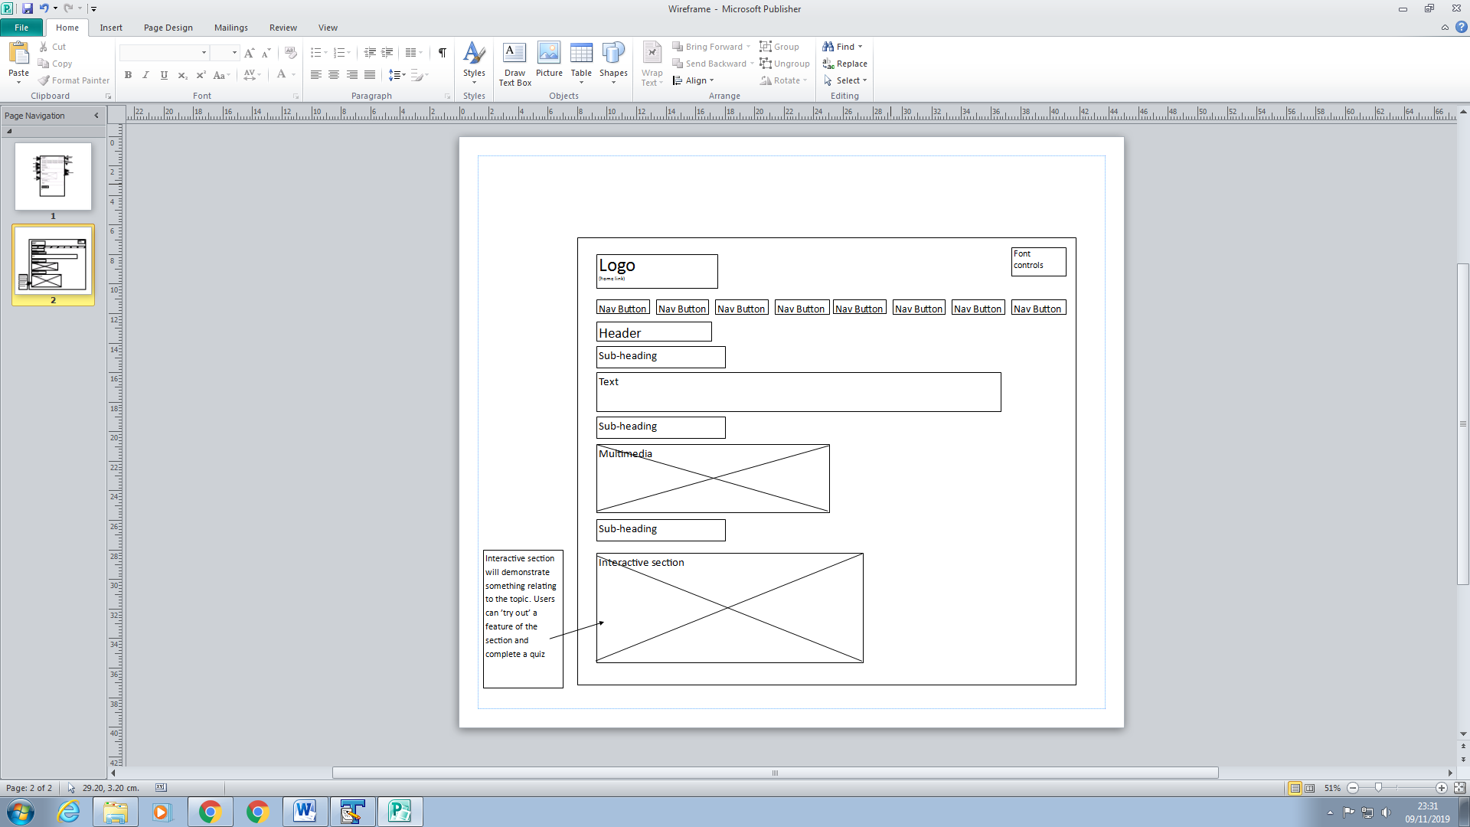

All other annotations are the same as previous wireframes

**Nav Map**

Although all pages are technically within the same physical page of the website, the use of JavaScript allows it to take different forms. So the concept of a ‘page’ is still there. There is a Nav Bar which allows access to any page, from any page, as shown in the Nav Map. No dead-end pages.

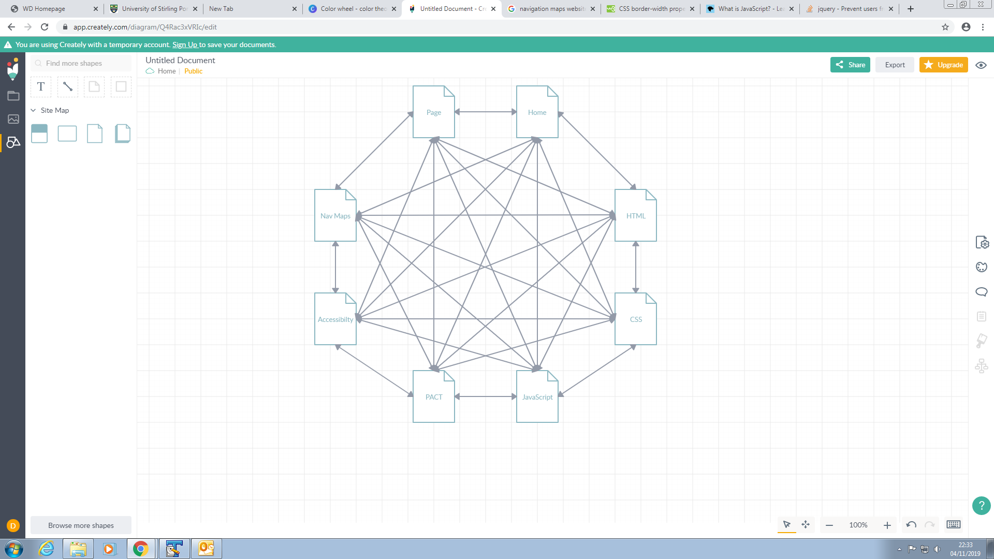

**Scenarios**

**Scenarios #1**

**Person:** Laura Johnson - 20 - Female – Computing Student

Motivations:

* receiving good grades
* learning new things
* having fun with her studies

Computer experience:

* Competent. Between intermittent and expert.

Accommodation required:

* Laura requires a soft pastel coloured background due to Dyslexia. This allows her to read the page much easier.

Frequency of visit:

* Relatively infrequent. She only uses the site when she needs to revise for a test of exam, which is maybe once every few months.

Discretionary or committed user?

* Discretionary user. If the website is too difficult to use then she will just leave and find another website to use for her revision.

**Activities:**

Goals:

* Increase productivity of revision
* Save time with an efficient method of revision that demonstrates things clearly
* Learn more about web design
* Find revision site that is accommodating of her Dyslexia.

Task:

* Revise web design for an upcoming class test topics on the test include HTML, CSS, JavaScript and design principles.

Task frequency:

* Will use the website in the lead up to an exam/test every few months. After some time she probably won’t fully remember how to use the interface so it must be designed in a way that makes the functionality obvious and easy to pick up.

Available time:

* Being a student that also works a part-time job while balancing all other parts of her life, Laura doesn’t have a lot of time. The content must be displayed clearly and concisely so that she is not spending unnecessary time looking for things.

**Context:**

Physical environment:

* Indoors. Comfortable, quiet, warm, dry, clean, relaxed. Strong internet connection.
* Internet café. Comfortable, noisy, warm, dry, somewhat relaxed. Potentially slow internet connection – could cause issue loading website.

Social environment:

* At home, Uni library, anywhere with internet – Laura can relax at home, sit silent section of the library or anywhere she can use her laptop with an internet connection. If she is using the website in the library it is important the website doesn’t make any unexpected sounds.
* Channels of communication: Primarily the website will be accessed using desktop/laptop but it could be accessed using a mobile phone, tablet or anything will access to the internet.

Organisational context:

* Laura often has to wake up early to attend her classes which are spread throughout the day. During her free periods she likes to make the most of her time and revise which requires her to go to a computer lab or the library to access the files as in that modules notes for each lecture are stored on the university system. She would prefer to be able to access notes on the same topic anywhere with an internet connection such as in Starbucks.
* She also wishes to access the notes on the train when travelling to and from her family home on her laptop using the trains Wi-Fi.
* Having a good revision website is important to Laura as it will give her the best chance of getting the grades she wants to receive her desired first class degree

**Technologies**

Input:

* Mouse/trackpad and keyboard, touch

Output:

* Screen

Communications:

* Device with internet connection. Desktop, Laptop, Mobile, Tablet, etc.
* Even on a poor internet connection the website should load in under 5 seconds to avoid frustration. General waiting times should be minimal.

Size of screen:

* Various sizes based on device used

Browser:

* Website should be viewable on any browser

**Scenario #2**

**Person:**  Euan Murray - 41 - Male – Computing Lecturer

Motivations:

* Students enjoying his lectures
* Teaching the Students new things
* Ensuring his students receive good grades

Computer experience:

* Expert. Very experienced as he has studied and taught the topic for many years

Accommodation required:

* None

Frequency of visit:

* Relatively frequent, maybe once a week or so. He uses the site when he needs to demonstrate something Web Design related to his classes.

Discretionary or committed user?

* Discretionary user. If the website is too difficult to use then he could just leave and find another website to use for his demonstrations or even create his own demonstrations.

**Activities:**

Goals:

* Teach his class something they didn’t know
* Find an accommodating revision site that he can recommend to his students for use at home
* Use online resources that tie well to topics on the syllabus
* Prepare students for exams and test

Task:

* Show some simple examples to his students in a lecture to supplement his teaching content to give greater context to what he is talking about.

Task frequency:

* Whenever required. Once a week or so to demonstrate the thing he is talking about.

Available time:

* In the context of a lecture he must open the website and be able to locate the -appropriate section quickly so he doesn’t waste teaching time or lose the students attention. This requires the content to be organised logically. After he locates the content everything must happen efficiently so that his lecture runs smoothly without long waits for anything.

**Context:**

Physical environment:

* Indoors. Standing, quiet, warm, dry, clean, somewhat stressful. Strong internet connection.

Social environment:

* Lecture theatre. High pressure with the whole class waiting on him opening the website and then local the content in a short period of time.
* Channels of communication: The website in this context will be accessed using desktop and displayed using a projector.

Organisational context:

* As a lecturer, Euan is very busy. He has to use examples of what he is talking about to better illustrate the concept, but with him being very busy he struggles to find the time to make these himself, so he uses the website.
* He also has students come to his office to ask questions so he sometimes has to load the website on the fly so it must load quickly

**Technologies**

Input:

* Mouse/clicking. Keyboard/typing. Touch.

Output:

* Screen/Projector

Communications:

* Device with internet connection. In this scenario a Desktop but Laptop, Mobile, Tablet, etc can be used too.
* Even on a poor internet connection the website should load in under 5 seconds to avoid frustration. General waiting times should be minimal

Size of screen:

* Various sizes based on device used

Browser:

* Website should be viewable on any up-to-date browser

**Design decisions**

**Heuristics/ general design rules**

* Contrast should be high to improve readability
* Appropriate use of whitespace and word spacing to improve readability
* Sensible colour palette
* Consistent font palette
* No clashing colours like red and green
* Keep it simple. A lot of the time its better
* Sensible use of scale and hierarchy. Example: Use of headings(h1) followed by subheadings(h3)

**TRUNK test and don’t make me think approach**

The design should allow the user to rapidly identify the following as a result of good design

* Site Id
* Page Name
* Sections and Subsections
* Local Navigation
* “You Are Here” Indicators
* Search

Everything’s purpose should be obvious. The user shouldn’t have to think about how to use the website so they can concentrate fully on the content.

**8 GOLDEN RULES**

**Strive for consistency**

Consistency is important because it helps users become familiar with the webpage so they can complete task more easily.

* All button will use the same styling so they are easy to recognise
* All pages will keep a consistent layout
* All pages will use the same colour scheme so they are all uniform
* Same menu/navigation on every page

**Keep users in control**

* All actions should be initiated by the user. They should never be surprised by an unwanted action.

**Enable frequent users to use shortcuts.**

This would be necessary for a more complex website but in this situation it is not required

* None. This would require overriding the browsers inbuilt shortcuts which could lead to confusion. For example, ctrl + h as a shortcut for the homepage but this is already a shortcut for the browsers history.
* In terms of general quicker ways of doing things, the website should already be rather simple and efficient in this way so there would be no need for shortcuts.

**Offer informative feedback**

This is needed to show the user what happened as a result of something they just did

* Buttons should highlight/change colour when hovered over to show which button they are about to click.
* Buttons should be highlighted when they are active to show the user which page they are on.
* Flashing cursor when typing in a text box
* Mouse arrow changes to a finger pointer when something is clickable

**Design dialogs to yield closure**

Something that allows the user to see the start, middle and end of an action in progress.

* In a slideshow of images, showing the user which slide they are on example : slide 1 of 2
* In a quiz then tell the user how many questions they have left

**Permit easy reversal of actions**

This is important in case the user does something unwanted by mistake

* Undo button/clear button
* Increase font size can be reversed with decrease font size
* Next image can be reversed with previous image

**Prevent errors**

* Recognise potential errors and prevent them.

**Reduce short-term memory load**

Things must be kept simple as humans in general have a bad short term memory. Recognise rather than recall.

* Useful thing could be tips on how to use something when you hover over it. Or even just text saying what to do
* Make things obvious so the user knows the function straight away without having to think

**ACCESSIBILITY**

Dyslexia

* The website will use dyslexia friendly colour scheme such as an off white back ground with off black text which has been found to be preferable by many dyslexic website users.
* Appropriate spacing between text

Colour blindness

* The website will also use a colour scheme that allows people with colour blindness so easily see the content.

Partial sight

* Users should have the option to increase font size

Partial hearing

* Website should not rely on audio to function correctly

Sensitivity to bright lights

* Avoid the use of bright whites and the likes. Keep more useful colours

**Prototype Description**

**What does the prototype contain and why?**

The prototype provides majority of the core functionality of the website just with some of the content missing. I think the level of implementation of the prototype allows you to get a good feel for the website and demonstrates the concept well.

Any content that is yet to be implemented is show with a text box.

I have not included an implementation of a quiz as I think everyone is familiar with how a quiz would work so this would be something to place in the final version

Includes appropriate:

* styling
* colour scheme
* page layout
* navigation
* use of multimedia(video, images, animation)
* use of interactivity
* level of accessibility

**Usability Testing – ATTENDED TESTING PRACTICAL**

**Sources:**

-All content taken from external sources has links within the website to where they are from.

-Lecture slides

- Golden rule information:

<https://www.interaction-design.org/literature/article/shneiderman-s-eight-golden-rules-will-help-you-design-better-interfaces>

<https://faculty.washington.edu/jtenenbg/courses/360/f04/sessions/schneidermanGoldenRules.html>

<https://medium.com/@sashika/j-k-or-how-to-choose-keyboard-shortcuts-for-web-applications-a7c3b7b408ee>

Scenarios:

<http://agilemodeling.com/artifacts/usageScenario.htm>

<http://hci.ilikecake.ie/requirements/pact.htm>

Libraries used:

* JQuery. Why? Made use of the hide, show and ready functions to allow for the different scenes/ the concept of a page

Works on up-to-date browsers